# P1#y1 CRUCKTON & DISTRICT PLOUGHING SOCIETY

**(Registered Charity Number 215009) Affiliated to the Society of Ploughmen**

**91st ANNUAL PLOUGHING COMPETITION**

**Saturday 14thSeptember 2024**

# Harnage Estates Ltd, Cressage.

**(By kind invitation of Simon & Justin Scott)**

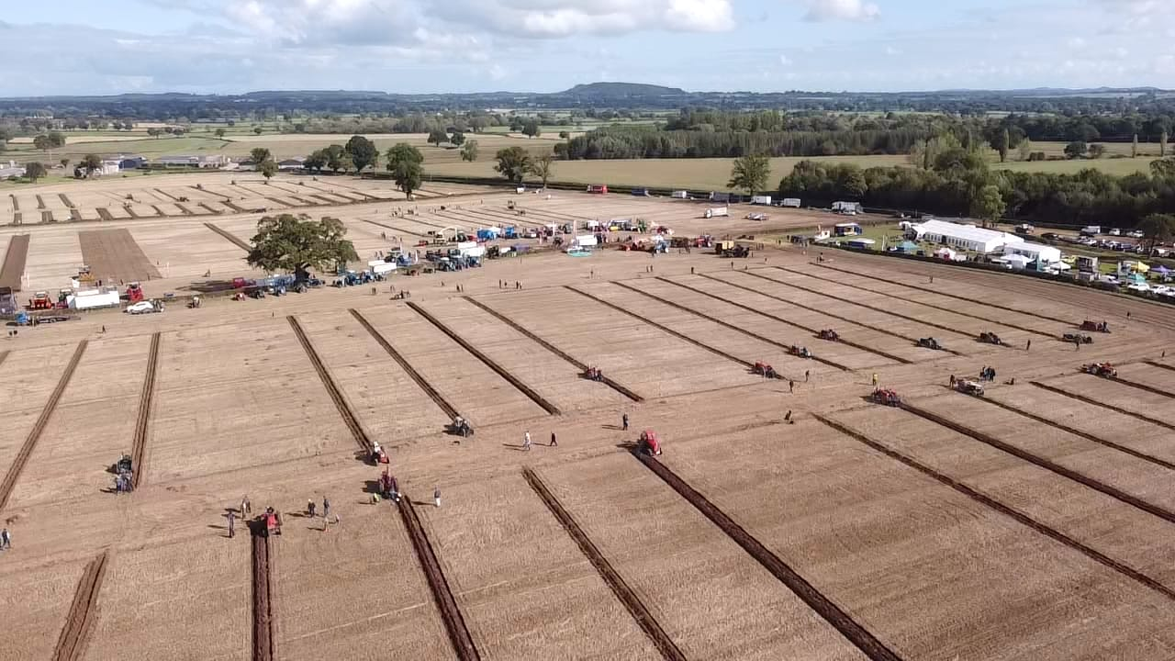

**HORSE & TRACTOR PLOUGHING**

**HORSES AND TURNOUTS, VINTAGE TRACTORS, STATIONARY ENGINES & IMPLEMENTS,**

**Official Programme**

**£2.00**

**BEST KEPT TRACTOR COMPETITION,**

**FORAGE, POTATOES & GRAIN SECTION**

**THRESHING DEMONSTRATION**

**Access the Society’s website:**[**www.crucktonploughing.org.uk**](http://www.ploughmen.co.uk/) **Email -** [**info@crucktonploughing.org.uk**](mailto:info@crucktonploughing.org.uk)

 **Cruckton & District Ploughing & Hedging Society**

A warm welcome to all Competitors, Judges and Visitors to the 91stAnnual Cruckton & District Ploughing Competition.

***Chairman`s Introduction***

This year we are returning to Harnage Grange, by kind permission of the Scott Families for our 91st Annual Ploughing Match. We were last here 44 years ago and we are pleased to see that some of the competitors from 1980 are competing again today.

We are blessed with a fantastic site, with an absolutely stunning backdrop of the Shropshire Countryside. Our Hosts have been extremely accommodating, in helping us organise what will be a fantastic day today.

You will be able to see ploughing through the ages, from the magnificent Shire Horse teams, through the Vintage and Classic era and to today`s modern Tractors. All competing for one of many trophies and shields available which is not limited to ploughing but also includes Best Turnout Classes (for both Horses and Tractors), best static exhibits and for best trade stand. There will also be the opportunity to see local machinery dealers showcasing the latest technology for preparing the ground prior to sowing, who will also be competing for a trophy for the best demonstration plot.

Today would not be possible without our Executive Committee, all of our Judges and Stewards, the Competitors, the Trade stands and the Spectators. I would like to thank each and every one of these people who help make Cruckton and District Ploughing Match the success that it is. I would particularly like to thank Karen for the huge amount of work that she puts in on the Match Day and the rest of the year.

Please take advantage of the passenger trailer which will be travelling round the field so that you will be able to see all of the Ploughing and Demonstrations, which will be returning back to the trade stand area where you can see a wide range of local trade stands and rural crafts. There will also be refreshments for you to enjoy and the chance to listen to the fairground organ.

Finally, I would like to wish all of the competitors the best of luck and say a huge thank you to everyone for your support today

**Ian Millington** (Chairman) **Karen Pritchard** (Secretary)

###### OFFICERS OF THE SOCIETY 2024

|  |  |
| --- | --- |
| President: | Mr N. Vickers, Sarn, Malpas |
| Chairman: | Mr I. Millington, Frodesley |
| Vice- Chairman: | Mr D. Perry, Prees |
| Treasurer: | Mr J Wilde, Criggion |

SAFETY ON SITE

THE SOCIETY ACCEPTS NO RESPONSIBILITY FOR ANY LOSS, INJURY OR DAMAGE AS A CONSEQUENCE OF ATTENDING THE MATCH.

KEEP CLEAR OF MACHINERY AND HORSES AT ALL TIMES

LOOK OUT FOR MOVING VEHICLES

**PAST PRESIDENTS**

|  |  |  |  |
| --- | --- | --- | --- |
| 1927 | Major A. E. Fielden, Knox | 1928 | Mrs K. Taylor, Cruckton Hall |
| 1929 | Mrs K. Taylor, Cruckton Hall | 1930 | Lady Leighton, Seed Merchant |
| 1931 | R. D. Bromley, Welsh Bridge (Seeds) | 1932 | Mrs Wingfield, Onslow |
| 1933 | R. D. Bromley, Welsh Bridge (Seeds) | 1934 | R. D. Bromley, Welsh Bridge (Seeds) |
| 1935 | Sir R. Leighton, Bt., Loton Hall | 1936 | J. Tudor, Polemere |
| 1937 | W. Norman Withers, Ford Hall | 1938 | Major A. E. Lees, Rowton Castle |
| 1939 | James A. Davies, Alberbury | 1944 | James A. Davies, Alberbury |
| 1945 | A. G. Clarke, Churncote | 1946 | G. Chapman, Bowbrook |
| 1947 | G. D. Rodenhurst, Preston Montford | 1948 | W. Tudor, Yockleton |
| 1949 | T. B. Bromley, Knox | 1950 | F. Lewis, Ford |
| 1951 | J. W. Gresty, Shoothill | 1952 | F. T. Roberts, Montford Bridge |
| 1953 | J. Arkwell Davies, Alberbury | 1954 | T. J. Clarke, Bicton |
| 1955 | D. Rodenhurst, Preston Montford | 1956 | W. Dudleston, Benthall |
| 1957 | F. R. Smith, Shawbury | 1958 | T. P. Powell, Rowton |
| 1959 | W. H. Jetson, Lea Cross | 1960 J. T. Davies, Eyton | |
| 1961 | G. H. Smith, Cardeston | 1962 | W. H. Holloway, Wattlesborough |
| 1963 | J. O. Jetson, Ford | 1964 | C. D. Bourne, Cardeston |
| 1965 | W. A. Roberts, Bowbrook | 1966 | C. Frank, Sutton Farm |
| 1967 | H. D. Birchall, Cruckton | 1968 | G. S. Adams, Sascott |
| 1969 | T. H. Ratcliff, Wem | 1970 | Lt. Col. G. R. Ellis, ERD, JP, FRAgS |
| 1971 | S. J. Tudor, Bomere Heath | 1972 | F. H. Millington, Shawbury |
| 1973 | R. B. Mullock, H.W.O. | 1974 | A.E. Tipton |
| 1975 | G. B. Clark, Churncote | 1976 | G. Morgan, Udlington |
| 1977 | C. M. Frank, Shrawardine Farm | 1978 | I. J. Faulkner, Acton Burnell |
| 1979 | I. J. Faulkner, Acton Burnell | 1980 | W. S. Powell, Hayes |
| 1981 | S. J. Roberts, Pattingham | 1982 | P. F. Williams, Yockleton |
| 1983 | G. H. Evans, Emstrey | 1984 | M. H. Holloway, Wattlesborough |
| 1985 | M. H. Holloway, Wattlesborough | 1986 | F. D. Cornes, Lyth Hill |
| 1987 | J. R. Jebb, Ford | 1988 | P. Jetson, Ford |
| 1989 | T. H. Roberts, Nobold | 1990 | N. J. P. Lewis, Pontesbury |
| 1991 | D. J. Clarke, Churncote | 1992 | R. G. S. Smith, Cardeston |
| 1993 | J. Davies, Eyton | 1994 | M. G. Holloway, Montgomery |
| 1995 | A. C. Bourne, Cardeston | 1996 | J. R. de Q. Quincey, Upton Magna |
| 1997 | J. Fairbanks, Builthy | 1998 | J. E. Cooke, Montford Bridge |
| 1999 | J. B. Mills, Meole Brace | 2000 | A. M. Jones, Aston Rogers |
| 2001 | P. Tudor, Edge Grove | 2002 | C. E. L. Morgan, Worthen |
| 2003 | C. E. L. Morgan, Worthen | 2004 | S. Roberts, Knockin |
| 2005 | D. W. L. Roberts, Halfway House | 2006 | C. Roberts, Fords Heath |

**PAST PRESIDENTS – PRESENT CONTINUED**

|  |  |  |  |
| --- | --- | --- | --- |
| 2007 | P. Davies, Hill Farm, Bausley | 2008 | P. Williams, Coedway |
| 2009 | Ms J. Lewis, Alberbury | 2010 | N. Price, Nesscliffe |
| 2011 | Mr D. Jones, Lydham | 2012 | J. Randles, Cruckton |
| 2013 | P Woodhall, Halfway House | 2014 | I Millington, Dorrington |
| 2015 | R Savage, Hanwood | 2016 | R Edwards, Rowton |
| 2017 | R. Edwards, Rowton | 2018 | J Wilde, Alberbury |
| 2019 | J Wilde, Alberbury | 2020 | B Rodenhurst, Pontesbury |
| 2021 | B Rodenhurst, Pontesbury | 2022 | D Roberts, Llanymynech |
| 2023 | Mrs W. Trow, Worthen | 2024 | N. Vickers, Sarn, Malpas |

**LIST OF JUDGES FOR 2024**

Mr T. Lloyd, Much Wenlock

Mr W. Williams, Dwyran

Mr J. Randles, Pontesbury

Mr G. Lamb, Whitchurch

Mr R. Morris, Tarporley

Mr J. Jebb, Ford

Mr B. Williams, Clun

Mr E. Watkin, Newtown

Mr H. Griffith, Pwllheli

Mr A. Cowell, Brimfield

Mr E. Owen, Abergele

Mr D. Roberts, Llanymynech

Mr D. Higgins, Longnor

Mr M. Jones

Mr W. Roberts

Mr I. Evans

Mr D. Morgan

Mr B. Naylor

Mr S. Scott / Mr J. Scott

**HORSES & TURNOUT**

**CLASSES 1 & 6**

**CLASS 2 & 3**

**CLASSES 4 & 5**

**CLASSES 7 & 8**

**CLASSES 9 & 10**

**CLASSES 11 & 12**

**STATIC TRACTOR**

**BEST KEPT TRACTOR**

**FORAGE**

**GRAIN**

**POTATOES**

**DEMO PLOTS & STATIC TRADE**

**Time Table of Events**

**10.00am Competitors commence ploughing**

**10.00am Judging of the Forage, Roots & Grain Classes**

**11.30-4pm Threshing Demonstration**

**12 onwards Tractor & Trailer tour of the working plots**

**2.30pm All TRACTOR Ploughing to finish.**

* 1. **pm All HORSE Ploughing to finish.**

**3.45pm Raffle to be drawn**

**4.00pm Cup Presentation**

**KEEP A LOOK OUT FOR THESE,**

**TAKING PLACE ON MATCH DAY**

Throughout the day a Vintage Threshing Machine will be in operation, do have a look and see how far modern day farming has advanced. (Weather Permitting)

In Action are:

54” Drum Threshing Machine

Coupled to a Wire Tie Stationary Baler owned by Richard & Tom Price

~~~~~~

Take a seat and enjoy the wonderful tunes coming from the Fairground Organ.

CRUCKTON PLOUGHING & HEDGING SOCIETY

***Registered Charity Number 215009***

[***www.crucktonploughing.org.*uk**](http://www.crucktonploughing.org.uk)

###### STEWARDS 2024

|  |  |  |  |
| --- | --- | --- | --- |
| **Chairman** | | Ian Millington |  |
| **Chief Stewards** | | Nigel Price & David Perry | |
| **Results** | | Linda Jebb, Sarah Maginess & Julia Holloway | |
| **Judges Steward** | Jackie Smith | | |
| **Trade Stands Safety Officer** | | Aubrey Jones |  |
| **Reception Office** | | Karen Pritchard, Wendy Trow, Linda Jebb, Eirwen Jebb, Jane Collins, Phil Collins & Stephanie Semple | |
| **Veterinary Surgeons**  **Gate & Car Park** | | Fyrnwy Equine Group | |
| **Chief Steward** | | Keith Faulkner | |
| **Stewards** | | Jimmy Wilde, Jim Davies, David Sheppard, Tudor  Davies, Allan Wynne, James Wynne, Chris Parkinson,  Richard Savage, Robert Faulkner, Becky Price,  Roger Price, Emma Diggory, Shaun Jones & Much  Wenlock YFC Members - Millie Preece, Ami Bower &  Rhys Jones | |
|  | |  | |
| **Horse Ploughing** | | Phil Pritchard |  |
| **Tractor Ploughing**  **Class 2 Beginners Mounted** | | | Rob Williams |
| **Class 3 Novice Mounted** | | | Rob Williams |
| **Class 4 Open Mounted Vintage** | | | Neville Lewis/ Stuart Eyres |
| **Class 5 Open Trailed Vintage** | | | Neville Lewis/ Stuart Eyres |
| **Class 6 Ferguson Class** | | | Phillip Davies |
| **Class 7 Classic Class Class 8 Classic Reversible** | | | Pete Jones Pete Jones |
| **Class 9 Open World Style**  **Class 10 Open Reversible European** | | | Gwyn Jones  Gwyn Jones |
| **Class 11 Open Reversible**  **Conventional Style** | | | Andrew Jebb |
| **Class 12 Beginners Reversible** | | | Andrew Jebb |
| **Best Kept Tractor** | | | Steve Bradley |
| **Forage & Potatoes** | |  | Linda Jebb |
| **Grain** | |  | Alan Bourne |

**EXTRACTS FROM THE RULES OF THE CRUCKTON PLOUGHING SOCIETY**

* + 1. All competitors to report to the Secretary’s tent on the field at 9am. ***ANY CHANGES TO MACHINERY DETAILED ON THE ENTRY FORM MUST BE NOTIFIED***
    2. **TIMING** Horse ploughing a total of 5 HOURS Finishing at 3.00pm. Tractor ploughing a total of 4 HOURS:

Commence ploughing at 10am. (*No Competitors allowed to start after 10.30am.)* 20 minutes for opening. Penalty of 2 points per minute for failure to finish opening on time. Ploughing will stop for up to 30 minutes for opening to be judged. Re-commence ploughing at 10.50am or on instructions of class steward.

**ALL TRACTOR PLOUGHING TO FINISH AT 2.30pm**

15 minutes extra time allowed for any competitor ploughing next to an un-claimed plot. Penalty for failing to finish plot at finishing signal 2 points per minute or part minute.

* + 1. Competitors must draw in and out on their marks.

PENALTY POINTS will be deducted if the correct depth of ploughing is not maintained (25 points per cm less than the required depth).

* + 1. Competitors will split to the higher number.
    2. In Horse ploughing the start must consist of 8 furrows.
    3. In Classes 2, 3, 4, 5, 6, 7 and 9 the start must consist of 11 or 12 furrows.
    4. In Classes 8,10, & 11 competitors must make a single furrow opening with a right-hand body. The start to consist of minimum 8 furrows. No marks will be awarded for an opening split which is turned the wrong way. Competitors must plough with the full number of furrows except at the start and finish.
    5. In Classes 1, 2, 3, 4, 5, 6, 7 and 9 finishes must be moulded to the competitor’s own start.
    6. In Class 12, the Beginners Class, advice may be asked of and given by the judges. No opening split.
    7. The plot must not be interfered with in any way by the competitor or any other person after being marked out by the Society.
    8. **NO SHAPING OF FURROWS BY HAND OR HAND-HELD INSTRUMENT, BY TREADING OR OTHER MANIPULATION WILL BE ALLOWED.**
    9. No persons other than the competitors and officials will be allowed on the plots during the time the competition is in progress except for an assistant to lead the horses if so desired. No person will be allowed to give instructions or assistance to any competitor except for the removal of sighting pegs.
    10. Tractors entered as ‘Vintage’ must have been in production before 31st December 1959. The ploughs in the vintage classes must have bodies that were made for the plough at the time of the original manufacture.
    11. Tractors entered as ‘Classic’ must have been in production before 31st December 1976.
    12. Competitors in the under 28 years old classes must be 28 or under on the 1st January 2024.
    13. **Competitors over 13 years and under 16 years of age, with suitable experience, may enter but must provide written proof of full insurance cover with their entry form and be accompanied by an adult.**
    14. A competitor breaking any rule laid down by the Society, either accidentally or intentionally, shall receive a maximum of 2 warnings from the Stewards. Upon a third infringement of a rule the competitor
    15. Any protest must be in the hands of the Secretary not later than 4pm on the day of the competitions. Any competitor objecting must deposit the sum of £5 with the Secretary. This will not be returned in the event of the objection proving frivolous. All protests must be made by the competitor. The Committee’s decision in all cases will be final.
    16. **SAFETY - Competitors must adhere at all times to the Society’s Safety Policy. Failure to do so will result in immediate** **disqualification.**
    17. **COMPETITORS MUST BE AWARE OF THE DANGER TO SPECTATORS AND GIVE WAY TO THEM AT ALL TIMES**
    18. All entries must be covered by an insurance policy & have full public liability Insurance. Please bring with you on Match Day as you may be required to show it.
    19. All qualifying classes will adhere to the Society of Ploughman rules.
    20. **SHOULD THERE BE A TIE FOR A PLACE IN ANY CLASS THEN THE ‘COUNTBACK SYSTEM’ WILL BE USED**.

**THE USE OF GLOBAL POSITIONING TECHNOLOGY, LASER BEAM OR ANY OTHER ELECTRONIC OR COMPUTERISED MEASURING DEVICES ARE NOT ALLOWED. ANYONE FOUND USING SUCH EQUIPMENT WILL BE DISQUALIFIED.**

## OUR 2024 MATCH SPONSORS

### P580#yIS1 P561#y2 **A VERY BIG THANKYOU** to the following Sponsors who have very kindly sponsored a Class or given a donation at this Year`s Match. Only through Sponsorship, Donations & Advertising can this match be held annually.











**TRADE STANDS ON SITE**

**TRADE STANDS ON SITE**

|  |  |  |
| --- | --- | --- |
| R.A.B.I | 08001 884444 |  |
| SHROPSHIRE RURAL SUPPORT | 03001 232825 |  |
| LINGEN DAVIES | 07713 681271 |  |
| THE HARRY JOHNSON TRUST | 01743 884275 |  |
| MIDLANDS AIR AMBULANCE | 07785 623383 |  |
| POWELLS PIES | 07967 828142 |  |
| THE FARMART | 01625 529900 |  |
| APLEY CASTLE CAKES | 07543 644173 |  |
| BCW AGRICULTURE | 01630 655722 |  |
| EDWARDS & FARMER LTD | 07375 899274 |  |
| WALFORD COLLEGE | 01939 262176 |  |
| AUNTY MO`S HANDMADE SCOTCH EGG | 07580 164813 |  |
| H.F.EVANS & SON | 01743 821619 |  |
| JOLLY BEE APIARY | 07554 179361 |  |
| TML AGRI SERVICES LTD | 01746 866710 |  |
| OLD MONTY CIDER | 01686 640899 |  |
| NFU MUTUAL SHREWSBURY | 01743 344743 |  |
| HAWKINS DRAINAGE  BROCKLEBY PIES  LYNS EVAN DESIGNS  MUCH WENLOCK YFC  THE DAIRY DOOR – MILLIE PREECE | 01948 830032  01664 813200  07871 563946 |  |
| PRICES MODELS AND PRINTS | 07870 807349 |  |
| SHROPSHIRE COUNCIL COMMUNITY HUB | 01743 254235 |  |
| DJM CONSULTING | 01746 714089 |  |
| P.J. EVANS | 01691 610377 |  |

**Cruckton Cup for Best Static Trade Stand**

**Winners……………………………………………………………………….**

###### WORKING DEMONSTRATION WITH TRADE STAND

|  |  |
| --- | --- |
| MORRIS CORFIELD, Broseley | 01952 881000 |
| TALLIS AMOS GROUP, Allscott | 01952 466900 |
| R.V.W. PUGH, Churchstoke, Powys | 01588 620545 |
| DUNCAN BRASSINGTON AGRICULTURAL, Burwarton | 01746 787983 |
| BATTLEFIELD MACHINERY LTD, Shrewsbury | 01743 464100 |
| ROBERT DAVIES MACHINERY LTD, Ford | 01743 850000 |

The ROBERT DAVIES TRADE STAND CUP for the Best Ploughing in Demonstration plots.

**Winners……………………………………………………………………….**



##### HORSE PLOUGHING

###### KINDLY SPONSORED BY

###### IN MEMORY OF THE LATE JAMES PICKSTOCK

###### & KINGSLEY PRESS

Class 1 HORSE PLOUGHING OPEN CLASS

Whole Work. Boats and Presses allowed. Minimum depth of furrow 13cms.

PRIZES: 1s £50 2nd £30 3rd £20.

|  |  |  |  |
| --- | --- | --- | --- |
| **1** | Paul | **Brook-Nolan** | Upper Boddington, Northants |
| **2** | Ethel | **Worthington** | Doncaster, South Yorkshire |
| **3** | Keith | **Chandler** | Doncaster, South Yorkshire |
| **4** | Gordan | **McKay** | Doncaster, South Yorkshire |
| **5** | Derek | **Hilton** | Staunton, Gloucestershire |
| **6** | Martin | **Kerswell** | Fordingbridge, Hants |
| **7** | Kevin | **Morris** | Mappleborough Green, Warwickshire |
| **8** | Bryony | **Gill** | St Austell, Cornwall |
| **9** | Haydn | **Lavin** | Cyronydd, Welshpool |

Winners: 1st ………. 2nd ………. 3rd ………..

**N.B. To enable the match to finish on time PENALTIES of 10 points each may be imposed if 8 furrows have not been completed by 12 noon or the plot is not finished by 3.00pm**

##### SPECIAL PRIZES

HP1 **THE RATCLIFFE PERPETUAL CUP** presented by

Messrs R.E. Ratcliffe Ltd., Worcs. For the winner of the Horse Ploughing Class

Winner: ………………. Reserve: ……………….

###### HP2 THE JOHN MARTIN PERPETUAL CHALLENGE

**CUP** presented by the late Bertram E. Pugh Esq. for the Runner up.

Winner: ………………. Reserve: ……………….

## HORSES AND TURNOUTS

##### KINDLY SPONSORED BY

##### IN MEMORY OF THE LATE JAMES PICKSTOCK

##### & BROWNS OF WEM

Class 1 FOR THE BEST PAIR OF HORSES WORKING ON THE FIELD

PRIZES: 1st £30 2nd £25 3rd £20.

Winners: 1st ………. 2nd ………. 3rd ……….

Class 2 FOR THE NEATEST AND SMARTEST TURNOUT WORKING ON THE FIELD

PRIZES: 1st £25 2nd £20 3rd £15

Winners: 1st ………. 2nd ………. 3rd ……….

Class 3 FOR THE BEST MARE OR FILLY WORKING ON THE FIELD

PRIZES: 1st £20 2nd £15 3rd £10

Winners: 1st ………. 2nd ………. 3rd ……….

Class 4 FOR THE BEST GELDING WORKING ON THE FIELD

PRIZES: 1st £15 2nd £10 3rd £8

Winners: 1st ………. 2nd ………. 3rd ……….



## SPECIAL PRIZES

H1 **THE PUGH & PURSELL PERPETUAL CHALLENGE CUP**

presented by Messrs Pugh & Pursell **for the Best pair of Horses entered in the Ploughing Classes.**

Winner: ……………………. Reserve: ……………….

H2 **THE ALF MILLWARD MEMORIAL TROPHY** presented by Mrs

Thomas in memory of Alf Millward **for the Neatest and Smartest Turnout.**

Winner: ……………………. Reserve: ……………….

H3 **JOHN DE QUINCEY MEMORIAL SALVER** presented in

memory of John De Quincey **for the Best Shire Horse.**

Winner: ……………………. Reserve: ……………….

H4 **THE REG INIONS PERPETUAL CHALLENGE CUP for the**

**Best Brood Mare.**

Winner: ……………………. Reserve: ……………….

H5 **THE GOLDEN GUINEA PERPETUAL TROPHY** presented by

Messrs. J.R. Partington and Co. Ltd. **for the Best Gelding.**

Winner: ……………………. Reserve: ………………...





# TRACTOR PLOUGHING

**Class 2 BEGINNERS MOUNTED CONVENTIONAL**

###### KINDLY SPONSORED BY

**BERRYS**

2 Furrow Plough - Any Tractor and Plough excluding World Style Ploughs, open to any competitor who has not won a first prize at any match. A prize for the highest YFC member will be offered in this Class.

PRIZES 1st £40 2nd £25 3rd £15

|  |  |  |  |  |  |  |
| --- | --- | --- | --- | --- | --- | --- |
| **10** | Ernie | **Carter** | Shropshire | Massey F 35X | 1962 | International B12 |
| **11** | Robert | **Gwynn** | Shropshire | David Brown | 1964 | Ransome |
| **12** | John | **Carpenter** | Powys | International B275 | 1957 | Ransome TS59 |
| **13** | Peter | **Hughes** | Shropshire | Zetor 3511 |  | Ransome TS59 |
| **14** | John | **Roberts** | Powys | Nuffield | 1957 | David Brown |
| **15** | Owain | **Dyfed** | Denbighshire | Ferguson | 1954 | David Brown |
| **16** | John | **George** | Shropshire | Ferguson FE35 |  | Ransome |
| **17** | Bob | **Gurney** | Shropshire | Ferguson TED 20 | 1952 | Ferguson |
| **18** |  |  |  |  |  |  |

Winners: 1st ………. 2nd ………. 3rd ………

**Our Ploughing Match in 2025**

**Will be held at Lythwood Farm,**

**Bayston Hill, Shrewsbury. SY3 0AA.**

**On Saturday 13th September**

**Please check our Website and Facebook page**

**for up to date information**



**Class 3 NOVICE MOUNTED VINTAGE**

**KINDLY SPONSORED BY**

**WACE MORGAN**

2 or 3 furrow mounted plough. Type of tractor is optional. **Open to anyone who has not won a Novice Class. Winner of this Class is not eligible to compete in this class the following Year.**

PRIZES – 1st £40 2nd £25 3rd £15

|  |  |  |  |  |  |  |
| --- | --- | --- | --- | --- | --- | --- |
| **19** | D.M. | **Jones** | Dyfed | Dexta | 1959 | Ransome Robin |
| **20** | Gwynfor | **Rowlands** | Gwynedd | John Deere 2030 | 1978 | Kverneland |
| **21** | Richard | **Egerton** | Shropshire | Ford 3000 | 1974 | Ransome |
| **22** | Jonathan | **Dunn** | Shropshire | Fordson | 1962 | IH |
| **23** | T.E.E. | **Kinsey** | Cheshire | Ferguson 35 | 1957 | Ransome |
| **24** | Lawrence | **Helmick** | Staffordshire | Ferguson TEF20 | 1955 | Ransome TS54 |
| **25** | Richard | **Lewis** | Shropshire | Massey F FE35 | 1959 | Ransome Robin |
| **26** | David | **Hughes** | Flintshire | International B275 | 1960 | Ransome TS54 |
| **27** | Roy | **Mathers** | Shropshire | Massey F | 1958 | Ferguson |
| **28** | Trevor | **Gwalchmai** | Powys | Massey F 148 | 1974 | Ransome |
| **29** | Murray | **Tibbott** | Powys | Ferguson TED20 | 1954 | David Brown |
| **30** | Brian | **Smith** | Shropshire | Ferguson | 1950 | Ferguson |
| **31** | Shaun | **Massey** | Shropshire | International B250 | 1958 | Ransome TS59 |
| **32** | Ryan | **Lindsay** | Shropshire | International 434 | 1968 | International B12 |
| **33**  **34** | Bob | **Cragg** | Cheshire | Fordson Dexta | 1960 | Ransome TS59 |

Winners: 1st ………… 2nd ………… 3rd ………….





**Class 4 OPEN MOUNTED VINTAGE**

**KINDLY SPONSORED BY**

**WILDES PLANT HIRE**

2 or 3 Furrow Mounted Plough and Tractor to have been in production before 31.12.59. Plough bodies and lift arms to be as original (no hydraulic top links). Minimum depth of furrow 15cms. Standard tail pieces allowed. Rules for Society of Ploughmen will apply.

PRIZES – 1st £50 2nd £30 3rd £15

|  |  |  |  |  |  |  |  |
| --- | --- | --- | --- | --- | --- | --- | --- |
| **35** |  | Tye | **Pountney** | Shropshire | Nuffield DM4 | 1954 | Ransome TS59 |
| **36** |  | Arthur | **Jennings** | Flintshire | Ferguson | 1957 | Ransome TS54 |
| **37** |  | Aled | **Rees** | Powys | David Brown 950 | 1959 | David Brown |
| **38** |  | Jack | **Lewis** | Shropshire | Massey F | 1959 | Ransome |
| **39** |  | Cliff | **Hamer** | Powys | Ferguson TEF 20 | 1954 | Star |
| **40** |  | George | **Wagg** | Shropshire | Massey F 35 | 1957 | Ransome |
| **41** |  | Rhys | **Jones** | Gwynedd | International B275 | 1961 | Ransome Robin |
| **42** |  | Andy | **Hughes** | Flintshire | Fordson Dexta | 1958 | Ransome TS59 |
| **43** |  |  |  |  |  |  |  |
|  |  |  |  |  |  |  |  |

Winners: 1st ………. 2nd ………. 3rd ……….

**WHY NOT JOIN THE SOCIETY?**

**ANNUAL MEMBERSHIP £18**

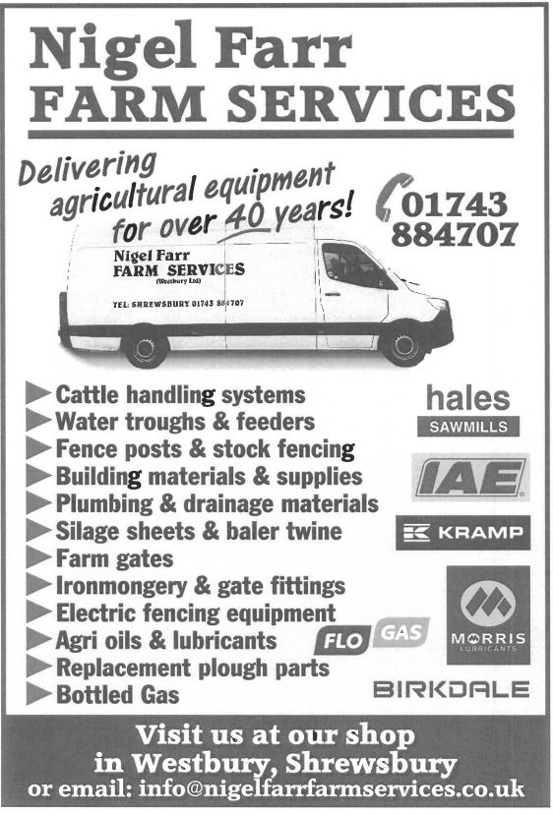

**Class 5 OPEN TRAILED VINTAGE**

###### KINDLY SPONOSRED BY CASTLE COUNTRY CLUB

2 or 3 Furrow Trailed Ploughs with Tractors in production before

31.12.59. Minimum depth of furrow 15cms. Rules for Society of Ploughmen apply.

|  |  |  |  |  |  |  |
| --- | --- | --- | --- | --- | --- | --- |
| **44** | Stuart | **Lamb** | Shropshire | Fordson | 1939 | Ransome |
| **45** | Les | **Evans** | Clwyd | Fordson | 1944 | Ransome Motac No3 |
| **46** | Andrew | **Buckley** | Shropshire | Nuffield | 1957 | Ransome |
| **47** | Derek | **Lloyd** | Shropshire | Fordson N | 1944 | Ransome RSLD |
| **48** | Brian | **Shaw** | Shropshire | Fordson N | 1941 | Ransome RSLD No9 |
| **49** | Harry | **Williams** | Cheshire | Fordson N | 1940 | Ransome RSLD No9 |
| **50** |  |  |  |  |  |  |
|  |  |  |  |  |  |  |

PRIZES – 1st £50 2nd £30 3rd £15

Winners: 1st …………... 2nd …………... 3rd ……………

**Class 6 FERGUSON PLOUGHING CLASS**

###### KINDLY SPONSORED BY JOHN PRICE - EVERYMANS

2 or 3 Furrows. For Ferguson Tractors and Ploughs. Minimum

|  |  |  |  |  |  |  |
| --- | --- | --- | --- | --- | --- | --- |
| **51** | Richard | **G. Jones** | Flintshire | Ferguson | 1954 | Ferguson |
| **52** | Charles | **Williams** | Gwynedd | Ferguson | 1950 | Ferguson |
| **53** | Ann | **Shropshire** | Shropshire | Ferguson | 1954 | Ferguson GP |
| **54** | Bryan | **Pugh** | Shropshire | Ferguson 20 | 1955 | Ferguson |
| **55** | Steve | **Jackson** | Cheshire | Ferguson TEF20 | 1954 | Ferguson |
| **56** |  |  |  |  |  |  |
|  |  |  |  |  |  |  |

depth of ploughing 15cms. Rules for Society of Ploughmen will apply.

PRIZES 1st £40 2nd £25 3rd £15

Winners: 1st …………. 2nd …………... 3rd ……



**Class 7 CLASSIC CLASS**

KINDLY SPONSPORED BY YOCKLETON ARMS

2 to 3 furrows – Tractor & mounted Plough built Pre Q Cab from 1960 to approximately 1976. No hydraulic top links. Minimum depth 17cms. Rules for the Society of Ploughmen will apply.

PRIZES 1st £50 2nd £30 3rd £15

|  |  |  |  |  |  |  |
| --- | --- | --- | --- | --- | --- | --- |
| **57** | Les | **Hanmer** | Shropshire | David Brown | 1969 | Ransome |
| **58** | Tony | **Shepherd** | Shropshire | IH B275 | 1959 | Ransome |
| **59** | Janet | **Vickers** | Cheshire | David Brown 950 |  | Ransome TS86 |
| **60** | Elwyn | **Lloyd** | Flintshire | Massey F 35X | 1963 | Ransome TS59 |
| **61** | John | **Davies** | Shropshire | International 434 | 1966 | Ransome TS59 |
| **62** | Mike | **Morgan** | Cheshire | Fordson Dexta | 1960 | Bamford |
| **63** | Gareth | **G. Jones** | Gwynedd | Massey F 65 | 1960 | Ransome TS86 |
| **64** | Edwyn | **Hughes** | Flintshire | David Brown | 1965 | David Brown |
| **65** | Roy | **Stokes** | Shropshire | David Brown 780 | 1969 | Ransome TS86 |
| **66** | Gwyn | **Evans** | Powys | Fordson Super Dexta | 1963 | David Brown |
| **67** | Tony | **Maiklem** | Shropshire | International 434 | 1968 | Ransome TS59 |
| **68** | Bob | **Boulton** | Shropshire | International | 1963 | Ransome |
| **69** | Mike | **Holloway** | Powys | IH 434 | 1968 | Ransome TS86 |
| **70** | Adrian | **Huffer** | Powys | Massey F 65 | 1958 | Ransome TS86 |
| **71** | Tom | **Morgan** | Shropshire | Massey F | 1968 | Ransome TS59 |
| **72** |  |  |  |  |  |  |
|  |  |  |  |  |  |  |

Winners: 1st ………..….2nd …………... 3rd ……………..



**Class 8 CLASSIC REVERSIBLE**

**KINDLY SPONSORED BY**

**ROBERT DAVIES MACHINERY LTD**

2-3 Furrows. Tractor and Mounted Plough built Pre Q cab from 1960 to approximately 1976. No hydraulic top links. Minimum depth 17cms.

PRIZES 1st £40 2nd £25 3rd £15

|  |  |  |  |  |  |  |
| --- | --- | --- | --- | --- | --- | --- |
| **73** | Richard | **Howells** | Powys | International 475 | 1975 | Ransome TSR102 |
| **74** | Andrew | **Millington** | Shropshire | Massey F 135 | 1966 | Ransome TS81 |
| **75** | Charlie | **Sankey** | Shropshire | Massey F 65 |  | Ransome TS81 |
| **76** |  |  |  |  |  |  |

Winners: 1st ………. 2nd ………. 3rd ………

**Class 9 OPEN WORLD STYLE**

**KINDLY SPONSORED BY TALLIS AMOS GROUP**

2-3 Furrow digger or semi digger plough. Minimum depth of 20mcms. Rules for the Society of Ploughmen will be strictly applied except that a time of 4 hours is allowed to plough the plot.

PRIZES 1st £50 2nd £30 3rd £20

|  |  |  |  |  |  |  |
| --- | --- | --- | --- | --- | --- | --- |
| **77** | Nigel | **Vickers** | Cheshire | Ford 5030 |  | Kverneland AB |
| **78** | Stuart | **Vickers** | Cheshire | Ford 5030 |  | Kverneland |
| **79** | Bryon | **Jones** | Powys | Case International |  | Fiskar |
| **80** |  |  |  |  |  |  |

Winners: 1st ………. 2nd ………. 3rd ……….

## TRACTOR PLOUGHING - SPECIAL PRIZES

**T2 THE GODFREY JONES PERPETUAL CHALLENGE CUP** presented by

Godfrey D. Jones for the **Best Work Done in Class 2.**

Winner: ………………………………Reserve………………………………….

**T2A THE BRIAN PUGH CHALLENGE CUP** presented by Mr Brian Pugh for the

**Best Work done in Class 2 by a Young Ploughmen – under 26.**

Winner……………………………………… Reserve………………………………………..

**T3 THE WILLIAM DAVIES MEMORIAL PERPETUAL CHALLENGE CUP**

presented by the late ES Davies in memory of his brother, for the **Best work done in Class 3.**

Winner: …………………………………. Reserve: ………………………………….

**T3A THE REGINALD TILDESLEY PERPETUAL CHALLENGE CUP** presented

by Messrs Reginald Tildesley for the **Best Work done by an under 26 in Class 3.**

Winner: …………………………………. Reserve: ………………………………….

**T4 THE EDWARD S. DAVIES MEMORIAL PERPETUAL CHALLENGE CUP**

for the **Best Work done in Class 4.**

Winner: …………………………………. Reserve: ………………………………….

**T5 THE BRIAN JAMES MEMORIAL PERPETUAL CHALLENGE CUP**

presented by the late Mrs Lilian James in memory of her husband, for the **Best work done in Class 5.**

Winner: …………………………………. Reserve…………………………………….

**T6 THE CRUCKTON CUP** for the **Best work done in Class 6.**

Winner: …………………………………. Reserve: ……………………………….

**T7 THE SHUKER PERPETUAL CHALLENGE CUP** presented by Messrs Shukers for the **Best work done by in Class 7.**

Winner: ……………………………………Reserve: ………………………………….

**T8 THE CADWALLADER CHALLENGE TROPHY** - awarded to the **best work done in Class 8.**

Winner: ……………………………………Reserve: ……………………………….

**T9 THE GEORGE EVANS PERPETUAL CHALLENGE CUP** presented by G.H.

Evans for the **Best work in Class 9**.

Winner: ……………………………………Reserve: ………………………………….

**T10 THE S.K.H. PERPETUAL CHALLENGE CUP** presented by Salopian Kenneth Hudson Ltd. for the **Best work done in Class 10**.

Winner: …………………………………. Reserve: ………………………………….

**T11 THE SILCOCK PERPETUAL CHALLENGE CUP** presented by R. Silcock & Sons Ltd. and K.S.C. Walters for the **Best work done in Class 11**.

Winner: ……………………………………Reserve: ……………………………….

**T12 THE LES ASPINALL TROPHY** for the **Best work in Class 12.**

Winner: ……………………………………Reserve: ……………………………….

**T12A THE MEREDITH & FOULKES PERPETUAL CHALLENGE CUP**

presented for the **Best work done by an under 26 year old in Class 12.**

Winner: ……………………………………Reserve: ……………………………….

**T12B THE DOWDESWELL PERPETUAL CHALLENGE CUP** presented by

Messrs Dowdeswell Engineering Co.Ltd. for the **Best work with a Dowdeswell Plough in Class 12.**

Winner: …………………………………. Reserve: ……………………………….

**T13 CRUCKTON SHIELD** awarded to the **highest placed under 26 competitors in**

**Classes 2 – 8** £25 will also be given by Cruckton Ploughing Society.

Winner: ……………………………………Reserve: ……………………………….

**T14 THE R.D. BROMLEY TROPHY** presented to the **Shropshire Young Farmers Club with the highest marks scored in ploughing classes.**

Winner: …………………………………. Reserve: ……………………………….

**T15 THE SONNY SMITH MEMORIAL SHIELD** awarded to **the highest placed under 26 in** **Classes 2 - 8**. A special Prize of £25 will be given by Mrs J Smith.

Winner: ………………………………… Reserve: ……………………………….

**T16 THE FRANK MILLINGTON PERPETUAL CHALLENGE CUP** presented

by Frank Millington for the **Best Work Done in Tractor Ploughing classes by a resident of Shropshire.** This will either be the winner of a class if a Shropshire Ploughman or the highest placed Shropshire Ploughman in the class.

Winner ………………………………………. Reserve…………………………………….

**T17 THE G.D. RODENHURST TROPHY** for the **Champion Tractor Ploughman.**

Winner………………………………………. Reserve…………………………………



**Class 10 OPEN REVERSIBLE EUROPEAN STYLE**

**KINDLY SPONSORED BY PROBALE**

2 -3 furrows**-** Rules for the Society of Ploughmen will be strictly applied except that a time of 4 hours is allowed to plough the plot.

PRIZES 1st £50 2nd £30 3rd £20

|  |  |  |  |  |  |  |
| --- | --- | --- | --- | --- | --- | --- |
| **81** | Ian | **Millington** | Shropshire | New Holland |  | Overum |
| **82** | Stewart | **Dicks** | Staffordshire | New Holland | 2008 | Kverneland |
| **83** | Chris | **Howell** | Shropshire | Massey F |  | Kverneland |
| **84** | Clive | **Roberts** | Shropshire | John Deere |  | Lemken |
| **85** |  |  |  |  |  |  |

Winners: 1st …………… 2nd ………. ….3rd …………….

**Class 11 OPEN REVERSIBLE CONVENTIONAL STYLE**

**KINDLY SPONSORED BY KINGSLEY PRESS**

3 or more furrows – Hydraulic top link allowed but no other attachments.

PRIZES 1st £40 2nd £25 3rd £15

|  |  |  |  |  |  |  |
| --- | --- | --- | --- | --- | --- | --- |
| **86** | Joe | **Hilditch** | Shropshire | Ford 8630 | 1991 | Kuhn |
| **87** | Robert | **Maddox** | Shropshire | Ford |  | Kverneland |
| **88** | James | **Roberts** | Shropshire | New Holland | 2022 | Kverneland |
| **89** |  |  |  |  |  |  |
|  |  |  |  |  |  |  |

Winners: 1st …………… 2nd …………... 3rd …………….





**Class 12 BEGINNERS REVERSIBLE**

###### 

No Split Opening. To be judged for good farm work. Minimum depth 20cms.

The Judges are allowed to advise competitors. Open to those who have not won a first prize at Cruckton.

Prizes 1st £40 2nd £25 3rd £15

|  |  |  |  |  |  |  |
| --- | --- | --- | --- | --- | --- | --- |
| **90** | Owen | **Jones** | Powys | John Deere |  | Kuhn |
| **91** | Henry | **Jones** | Shropshire | Case Puma 165 |  | Kverneland ED85 |
| **92** |  |  |  |  |  |  |

 Winners: 1st ………. 2nd ………... 3rd ……………





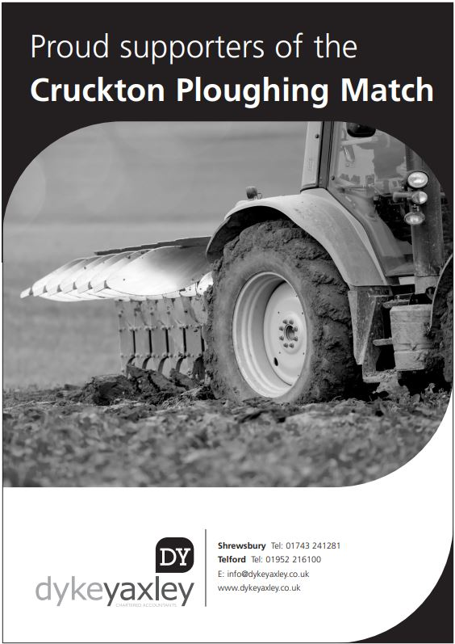



###### 

###### 

###### BEST KEPT TRACTOR COMPETITION

###### KINDLY SPONSORED BY JOHN PRICE - EVERYMANS WINE & SPIRITS

**All tractor drivers COMPETING IN THE PLOUGHING CLASSES are invited to enter for a BEST KEPT TRACTOR COMPETITION to be judged while ploughing is taking place.** Points will be awarded for the cleanliness, freedom from defects and general condition taking into account the age of the tractor.

PRIZES: 1st £10 2nd £5 3rd £3.

**SPECIAL PRIZE: The Best Kept Tractor Pre 31st December 1976, will receive the JOHN HALL MEMORIAL TROPHY**

Winner: …………………………………… Reserve: ……………………………….

SPECIAL PRIZE: The best tractor from 1st January 1977 to Present date, will receive the DAVID MORRIS TROPHY

Winner: …………………………………… Reserve: …………………………



## VINTAGE TRACTORS, IMPLEMENTS AND STATIONARY ENGINES

###### KINDLY SPONSORED BY JOHN PRICE - EVERYMANS WINES & SPIRITS

|  |  |  |
| --- | --- | --- |
| **VINTAGE TRACTORS** |  |  |
| Bryan Hill, Monkhopton | 1963 | McCormick International B414 |
| John Fildes, Annscroft | 1938 | Allis Chalmers W.F. |
| Paul & Wilma Dillow, Minsterley | 1986 | Ford 7710 |
| Paul & Wilma Dillow, Minsterley | 1989 | Ford 7810 |
| Paul & Wilma Dillow, Minsterley | 1994 | Ford 7740 |
| David Jones, Halfway House | 1948 | Massey Harris 55 |
| Richard Dorrell, Much Wenlock | 1983 | Marshall 802 |
| John Davies, Frodesley | 1967 | County 954 |
| John Davies, Frodesley | 1952 | Ransome Trailed Combine |
| Richard Wilkes, Much Wenlock | 1952 | Diesel Major |
| Richard Wilkes, Much Wenlock | 1961 | Power Major |

**SPECIAL PRIZE: THE GEOFFREY HODGES MEMORIAL TROPHY** will be

awarded to **the best exhibit in the static vintage section**. The trophy is presented by Mr J.R. Hodges in memory of his father.

Winner: …………………………………… Reserve: ……………………………….

**SPECIAL PRIZE: THE P & W TROPHY** will be presented to the **best static Classic Tractor manufactured after 1964.**

Winner: …………………………………… Reserve: ………………………………



**FORAGE CROPS**

**KINDLY SPONSORED BY NFU MUTUAL, SHREWSBURY**

**ENTRY FEES: Non-Members £1; Members 50p.**

Entries can be made beforehand or at the Match. Multiple entries are allowed in the forage classes

PRIZES: 1st £5 2nd £3 3rd £2 (**Only one entry per class from any competitor will receive a prize)**

**Class 1** A 3KG SAMPLE of GRASS SILAGE

Winners: 1st ………................. 2nd ……………...……. 3rd ……………………

**Class 2** A SAMPLE of 2024 HAY

Winners: 1st ………................. 2nd ……………...……. 3rd ……………………

**Class 3** A Turf – 12ins x 12ins

Winners: 1st ………................. 2nd ……………...……. 3rd ……………………

**Class 4** FOUR FODDER BEET

Winners: 1st ………................. 2nd ……………...……. 3rd ……………………

**Class 5** HEAVIEST BEET, to be shown washed but untrimmed.

Winners: 1st ………................. 2nd ……………...……. 3rd ……………………

**Class 6** SIX COBS OF MAIZE*.*

Winners: 1st ………................. 2nd ……………...……. 3rd ……………………

**Class 7** HEAVIEST COB OF MAIZE

Winners: 1st ………................. 2nd ……………...……. 3rd ……………………

###### SPECIAL PRIZE

R1 **THE ASTON PERPETUAL CHALLENGE CUP** presented by

S. Aston & Son Ltd. to the exhibitor gaining the greatest number of points in the Forage Classes 1 – 7 inclusive.

Winner: ………………………………… Reserve: ……………………………

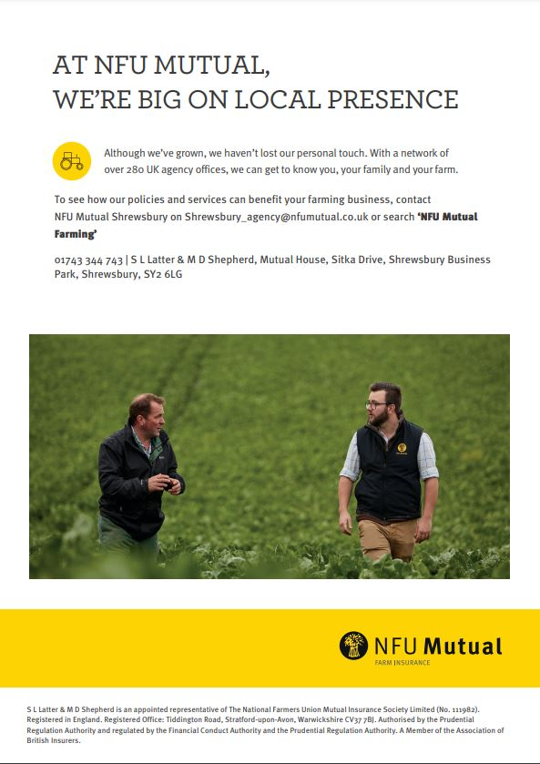

**GRAIN**

**KINDLY SPONSORED BY BLAKEMORE FOUNDATION**

**ENTRY FEES: Non-Members £1; Members 50p**.

Entries can be made beforehand or at the Match.

Samples to be exhibited in bags provided by the Society. Name of the variety to be stated on exhibit. **One entry per variety per exhibitor**.

PRIZES: 1st £5; 2nd £3; 3rd £2 **(Only one entry per class from any competitor will receive a prize)**

**Class 1** Sample of 3kg MALTING BARLEY

Winners: 1st ………................. 2nd …………….……. 3rd ……………………

**Class 2** Sample of 3kg FEED BARLEY

Winners: 1st ………................. 2nd …………….……. 3rd ……………………

**Class 3** Sample of 3kg OATS

Winners: 1st ………................. 2nd …………….……. 3rd ……………………

**Class 4** Sample of 3kg MILLING WHEAT

Winners: 1st ………................. 2nd …………….……. 3rd ……………………

**Class 5** Sample of 3kg FEED WHEAT

Winners: 1st ………................. 2nd …………….……. 3rd ……………………

**Class 6** Sample of 3kg SPRING WHEAT

Winners: 1st ………................. 2nd …………….……. 3rd ……………………

**Class 7** Sample of 3kg PEAS OR BEANS

(If enough entries are received this class will be divided)

Winners: 1st ………............... 2nd …………………… 3rd ………………….

**Class 8** 12 heads of MALTING BARLEY

Winners: 1st ………............... 2nd …………………… 3rd ………………….

**Class 9** 12 heads of OATS

Winners: 1st ………............... 2nd …………………... 3rd …………………

**Class 10** 12 heads of WHEAT

Winners: 1st ………............... 2nd …………………. 3rd ………………….

**Class 11** A 3kg sample of RAPE SEED

Winners: 1st ………............... 2nd …………………. 3rd ………………….

###### SPECIAL PRIZE

**G1 THE H. FITCHETT PERPETUAL CHALLENGE CUP** to the

exhibitor gaining most points in the Grain Classes Nos. 1 – 11. Points will be awarded on the basis of 1st 5 points, 2nd 3 points, 3rd 1 point.

More than one entry per class can count towards the points scored

Winner: ………………………………… Reserve: ……………………………





**POTATOES**

**KINDLY SPONSORED BY SCOTT & NEWMAN**

**Entry Fees: Non-Members £1; Members 50p**.

Entries can be made beforehand or at the Match.

All exhibits must have been grown by the exhibitor and each entry **must be of a different variety.**

**PRIZES: 1st £5 2nd £3 3rd £2**

**(Only one entry per class from any competitor will receive a prize)**

**Class 1 13kg WHITE POTATOES**. To be show unwashed

in transparent polythene bags. Name of variety to be shown.

Winners: 1st ………............... 2nd …………………. 3rd ………………….

**Class 2 13kg COLOURED POTATOES**. To be shown

unwashed in transparent polythene bags. Name of variety to be shown.

Winners: 1st ………............... 2nd …………………. 3rd ………………….

**Class 3 SIX WHITE OVAL POTATOES** to be staged washed on a plate. Variety to be named.

Winners: 1st ………............... 2nd …………………. 3rd ………………….

**Class 4 SIX ROUND WHITE POTATOES** to be staged washed on a plate. Variety to be named.

Winners: 1st ………............... 2nd …………………. 3rd ………………….

**Class 5 SIX COLOURED POTATOES** to be staged washed on a plate. Variety to be named.

Winners: 1st ………............... 2nd …………………. 3rd ………………….

**Class 6 HEAVIEST POTATO**

Winners: 1st ………............... 2nd …………………. 3rd ………………….

##### SPECIAL PRIZE

**P1 THE RAY OWEN PERPETUAL CHALLENGE CUP** to the

exhibitor gaining most points in the Potato classes. Points will be awarded on the basis of 1st 5 points, 2nd 3 points, 3rd 1 point. More than one entry per class can count towards the points scored for this trophy.

Winner: ………………………………… Reserve: ……………………………



#### 

#### IF YOU WOULD YOU LIKE TO BE AT OUR PLOUGHING MATCH NEXT YEAR 2025 TO HAVE A DEMO PLOT, TRADE STAND, COMPETE IN THE PLOUGHING, ENTER A CLASS OR SPONSOR ONE OF OUR CLASSES .. THEN PLEASE CONTACT OUR SECRETARY: EITHER BY PHONE, EMAIL, WEBSITE OR OUR FACEBOOK PAGE:

Mrs Karen Pritchard

Keepers Cottage, Hinwood Road, Westbury, Shrewsbury SY5 9PB

TEL: 01743 884628

Website - [www.crucktonploughing.org.uk](http://www.crucktonploughing.org.uk/) Email - [info@crucktonploughing.org.uk](mailto:info@crucktonploughing.org.uk)

Facebook - Cruckton & District Ploughing

**& Hedging Society**

**Our Ploughing Match in 2025**

**Will be held at Lythwood Farm,**

**Bayston Hill, Shrewsbury. SY3 0AA.**

**On Saturday 13th September**

**Please check our Website and Facebook page for up to date information**

**CRUCKTON PLOUGHING MATCH SITES 1927-2006**

|  |  |  |  |
| --- | --- | --- | --- |
| 1927 | Holly Bank, Cruckton | 1969 | Benthall, Ford |
| 1928 | Holly Bank, Cruckton | 1970 | Polemere, Yockleton |
| 1929 | Benthall, Ford | 1971 | Bank House, Yockleton |
| 1930 | Upper House, Alberbury | 1972 | Churncote |
| 1931 | Holly Bank, Cruckton | 1973 | Halston Farm, Lea Cross |
| 1932 | Lower Farm, Preston Montford | 1974 | Albright Hussey |
| 1933 | Lower Farm, Ford | 1975 | Upper Brompton, Cross Houses |
| 1934 | Lower Farm, Ford | 1976 | Little Shrawardine |
| 1935 | Lower Eyton, Alberbury | 1977 | Lower Eyton, Alberbury |
| 1936 | Holly Bank, Cruckton | 1978 | Aston Hall, Aston Rodgers |
| 1937 | Manor House, Ford | 1979 | Albright Hussey |
| 1938 | Lower Eyton, Alberbury | 1980 | Harnage Grange, Cressage |
|  | **WW2** | 1981 | Halston Farm, Lea Cross |
| 1944 | Lower Farm, Ford | 1982 | Upper Brompton, Cross Houses |
| 1945 | Holly Bank, Cruckton | 1983 Heath Farm, Knockin | |
| 1946 | Dinthill, Ford | 1984 | Atcham Grange |
| 1947 | Lower Eyton, Alberbury | 1985 | Wykey Farm, Ruyton XI Towns |
| 1948 | Churncote& Preston Montford | 1986 | Oakfield, Cruckton |
| 1949 | Benthall, Ford | 1987 | Rock Farm, Stanton |
| 1950 | Rowton | 1988 | The Rhos, Llandrinio |
| 1951 | Lynches & Upper House Yockleton | 1989 | Day House, Nobold |
| 1952 | Dinthill, Ford | 1990 | Weir Farm, Montford Bridge |
| 1953 | Holly Bank, Cruckton | 1991 | Hanley Hall, West Felton |
| 1954 | Lower Eyton, Alberbury | 1992 | Lower Eyton, Alberbury |
| 1955 | Benthall, Ford | 1993 | Lythwood, Bayston Hill |
| 1956 | Edgebold | 1994 | Hopton Farm, Nesscliffe |
| 1957 | Preston Montford | 1995 | Aston Hall, Aston Rogers |
| 1958 | Upper Eyton, Alberbury | 1996 | Kinton Farm, Nesscliffe |
| 1959 | Little Shrawardine | 1997 | The Rolly, Knockin |
| 1960 | Churncote | 1998 | Preston Montford |
| 1961 | Benthall, Ford | 1999 | Walford College, Baschurch |
| 1962 | Acton Pigott | 2000 | Hanley Farm, West Felton |
| 1963 | Lower Eyton, Alberbury | 2001 | Heath Farm, Knockin |
| 1964 | Calcott, Bicton | 2002 | Benthall, Ford |
| 1965 | Wattlesborough Hall | 2003 | Crankwell, Chirbury |
| 1966 | Lythwood, Bayston Hill | 2004 | The Broadlands, Baschurch |
| 1967 | Upper Eyton, Alberbury | 2005 | Chilton Farm, Atcham |
| 1968 | **National Match at Eyton & Benthall** | 2006 | Court Calmore, Montgomery |

**CRUCKTON PLOUGHING MATCH SITES 2007 - PRESENT**

|  |  |  |  |
| --- | --- | --- | --- |
| 2007 | Hayes Farm, Alberbury | 2019 | Upper Eyton, Alberbury |
| 2008 | Dowton Farm, Uffington | 2020 | Covid Outbreak |
| 2009 | Eyton, Alberbury | 2021 | Kinton Business Park, Kinton |
| 2010 | Hanley Hall, West Felton | 2022 | Silverdale, Yockleton |
| 2011 | Crankwell, Chirbury | 2023 | Hayes Farm, Alberbury |
| 2012 | Oakfield & Holly Bank, Cruckton | 2024 | Harnage Estates Ltd, Cressage |
| 2013 | Coton, Ruyton XI Towns |  |  |
| 2014 | Wood Hall Farm, Hanwood |  |  |
| 2015 | Hanley Hall, West Felton |  |  |
| 2016 | Silverdale, Yockleton |  |  |
| 2017 | Wykey Farm, Ruyton XI Towns |  |  |
| 2018 | Norton Farm, Condover |  |  |

A Brief History of Cruckton Ploughing Society

The first Cruckton Ploughing Match took place in 1927. The society had only been formed that year as a result of two local farmers having a bet, as to who could plough the straightest furrow. This wager took place in the Hare & Hounds public house at Cruckton, where the society continued to hold their meetings for many years.

The prizes for 1st, 2nd & 3rd was £5, £3 and £2, amazing really because wages at that time were the equivalent of £1.50 for a 56 hour week! This

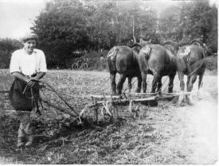photo was taken in 1927 at the 1st Cruckton Ploughing Match.

Tractor ploughing classes were introduced for the first time in 1939. Within a few years the number of these grew rapidly overtaking

the number of horse ploughing classes, but Cruckton retained the honour of staging the

British Isles Championships for Horse Ploughing.

After an enforced break during WWII, Cruckton once again became a major fixture in the farming calendar. The only other time the society was unable to hold a match was in 1967 due to a Foot & Mouth outbreak in the county.

Hedge laying competitions have been a regular sight at many matches and organising these events relies on the suitability of the match site. This year we are unable to do a competition.

By the 1950's members had represented Cruckton at the British Championships and also at the International's. On the "Achievements" page of our website there is a list of our members successes. We also have very keen members who are more than willing to judge at other ploughing competitions, domestic and international.

Usually, the match is held on a late Saturday in September and attracts more than 90 competitors alongside vintage machinery and classes for forage, roots, grain and a few novelty classes. Total prize money exceeds

£1600 and trophies valued at over £25,000 are up for grabs. The society has always been well supported by local companies’ trade stands and sponsorship, for which their support is very much appreciated.

In 1958, the prime minister, Harold McMillan, visited the Cruckton ploughing match as part of his ‘Premier meets the People visits! The site was at Upper Eyton, Alberbury and it was a bit muddy under foot. This visit was captured on film and can be seen today as part of the Pathé new archive on www.Youtube/watch.

***In order to continue the history of holding this Match we need your support; be it as a Sponsor, Trade Stand, society member or a visitor. If you can help with Sponsorship or wish to have a stand at next year’s Match, then please contact the Secretary either by emailing or come and see us at the Secretary`s Office*.**

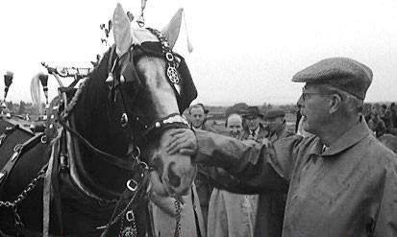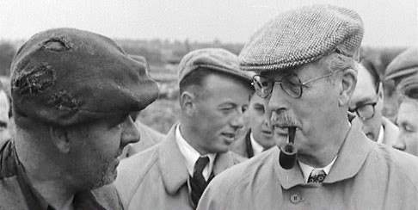

We would like to say a

**BIG THANKYOU** to….

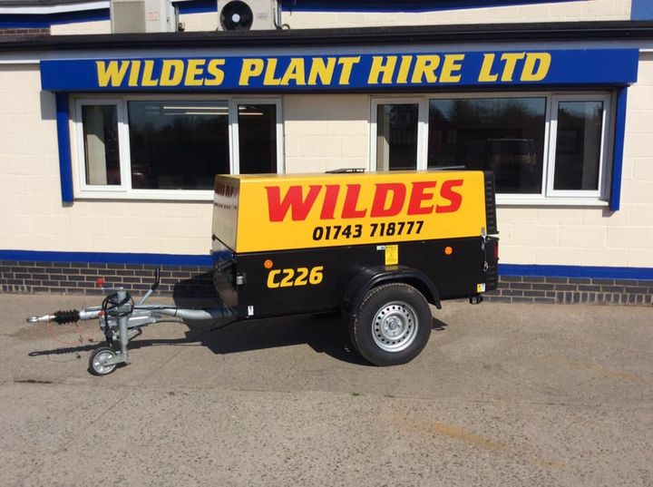

David from **Wilde`s Plant Hire** for kindly loaning us again a Generator to use on Match Day..

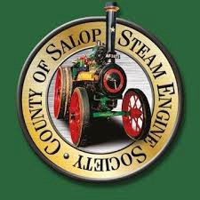

Maggy from the **County of Salop Steam Engine Society** who kindly lets us use their Passenger Trailer for our tours of the Ploughing plots on Match Day..

**Morris Corfield**

for kindly loaning us a Tractor to use on the Passenger trailer rides..



### 

### **Battlefield Machinery Ltd**

### for kindly loaning us a Gaitor to use on Match Day..

### & finally

to **Much Wenlock YFC**

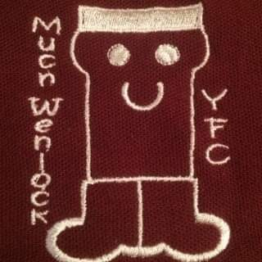 for all their help on the Day..

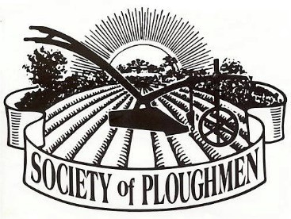

#### CRUCKTON PLOUGHING & HEDGING SOCIETY

***Registered Charity Number 215009***

##### Entry to all ploughing classes is free to members of the Society. Annual membership still only costs

**£18. Perhaps you would like to consider supporting the work of the Society by becoming a member. If so, contact our secretary and check out our website for information about our activities -** [**www.crucktonploughing.org.uk**](http://www.crucktonploughing.org.uk/)

**President: Mr N Vickers Sarn, Malpas Chairman: Mr I Millington, Frodesley**

**Vice-Chairman:** **Mr D Perry, Prees**

**Secretary: Mrs K Pritchard, Westbury, Shrewsbury**

**Treasurer: Mr J Wilde, Criggion, Shrewsbury**

[***www.crucktonploughing.org.uk***](http://www.crucktonploughing.org.uk/)

